Date of Hearing: June 29, 2021

BILL NO. | SB 218 | SB 239 | SB 269 | SB 288
ACTION VOTED ON | Do pass and re-refer to Cmte on Jud., Rec. Consent | Do pass and re-refer to Cmte on Appr., Rec. Consent | Do pass and re-refer to Cmte on Appr., Rec. Consent | Do pass and re-refer to Cmte on Jud., Rec. Consent
 | Aye : No | Aye : No | Aye : No | Aye : No
Grayson, Chair | X : | X : | X : | X :
Chen, V. Chair | X : | X : | X : | X :
Bauer-Kahan | X : | X : | X : | X :
Burke | X : | X : | X : | X :
Cervantes | X : | X : | X : | X :
Choi | X : | X : | X : | X :
Gabriel | X : | X : | X : | X :
Cristina Garcia | X : | X : | X : | X :
Nguyen | X : | X : | X : | X :
Petrie-Norris | X : | X : | X : | X :
Stone | X : | X : | X : | X :
Wicks | X : | X : | X : | X :
 | Ayes : 12 | Ayes : 12 | Ayes : 12 | Ayes : 12
 | Noes : 0 | Noes : 0 | Noes : 0 | Noes : 0

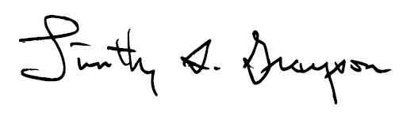

RECEIVED: _____________
___________________________________________________, CHAIR

Date of Hearing: June 29, 2021

BILL NO. | SB 360 | SB 497 | SB 531
ACTION VOTED ON | Do pass, to Consent | Do pass and re-refer to Cmte on Hum. S., Rec. Consent | Do pass and re-refer to Cmte on Jud.
 | Aye : No | Aye : No | Aye : No | Aye : No
Grayson, Chair | X : | X : | X :
Chen, V. Chair | X : | X : | Not Voting
Bauer-Kahan | X : | X : | X :
Burke | X : | X : | X :
Cervantes | X : | X : | X :
Choi | X : | X : | Not Voting
Gabriel | X : | X : | X :
Cristina Garcia | X : | X : | X :
Nguyen | X : | X : | Not Voting
Petrie-Norris | X : | X : | X :
Stone | X : | X : | X :
Wicks | X : | X : | X :
 | Ayes : 12 | Ayes : 12 | Ayes : 9 | Ayes : 0
 | Noes : 0 | Noes : 0 | Noes : 0 | Noes : 0

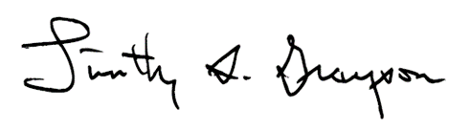

RECEIVED: _____________
___________________________________________________, CHAIR

